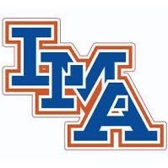

2021 B Team Football Roster

Bryson Pepper #1
Rob Briggs #2
Jackson Timmons #3
Cade Hodge #4
Grainger Powell #5
Robbie Robertson #6
Corbin Donaheau #7
Jayden Hicks #8
Andrew Gamble #9
Nathan Hyde #10
Heyward Moore #11
Landon Duke #12
Joey Hatchell #13
Asher Sanders #15
Maverick Shepker #20
Griffin Coulter #21
Pierson Gamble #23
Hudson Harris #30
Hunter Rogers #31
Logan Abernathy #41
Cody Taylor #42
Eli Gamble #44
Ben Sanders #50
Harrison Denny #51
Dana Moberg #52
Wyatt Simpson #53
Gavin Mathis #54
Eli Sandifer #56
Tristen White #57
John Gainey #58
Cayden Hardey #60
Avery Denny #61
Crosby Tisdale #63
Dylan Kester #64
Cooper Newman #66
Colby Ridgeway #67
Wyatt Welch #71
Hunter Stanfield #72
Colton Ehlinger #84

Head Coach: Al Nelson Assistant Coaches: Barry Hatfield & Robbie Briggs

