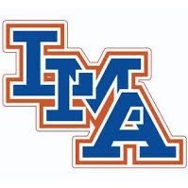
LMA Varsity Lacrosse
Reid Moore 3
Nate Rowe 4
Cam Barrineau 6
Trey Glenn 7
Dalton Huggins 13
Hunter Morris 15
Gavin Parler 17
Ethan Hyde 23
Brock Tamburello 25
Hunter Arrants 30
Elliott Harris 36
Caden Tamburello 48
Landon Lasseigne 55
Nik Ambroggio 62
Cassandra Schuessler 88

