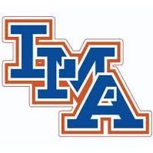

LMA Golf 2021
Zane Flemming
AJ Nelson
Bryce Parlor
Cantey Gardner
Riley Overstreet
Bryson Watt
Heyward Moore
Cooper Newman
Robbie Robertson
Parker Tisdale
Nolan Osteen

