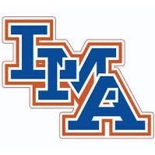

2021 Varsity Cheer Roster

Ava Ambroggio
Emily Anderson
Hayleigh Brunson
Anna Easley
Macy Jans
Ansley Nelson
Ansley Wright
Karley Brown
Mary Grace Carraway
Porter Davis
Anna Kate DuBose
Eva Eaddy
Parker Pendarvis
Layken Caines
Katie Clark
Haley Cruse
Ansley Elmore
Gracyn Iler
Laney Wright

Head Coach: Robin Page
Assistant Coach: Allison Evans

