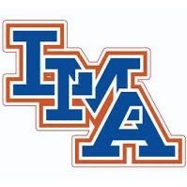

2021 Cross Country Roster

Emma Danback
Bre Finney
Drew Beard
Brody Secosky
Meredith Coffey
Morgan Conklin
Caden Tamburello
Rylee Driggers

Head Coach: Caroline Buyck
Assistant Coach: Jodi Danback

