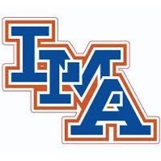

2020–2021 Varsity Cheer Roster
Seniors:
Payton Braz
Brooke Reed
Carly Wharton
Juniors:
Ava Ambroggio
Emily Anderson
Hayleigh Brunson
Macey Jans
Gracyn Nalley
Ansley Nelson
Ansley Wright
Sophomores:
Karley Brown
Mary Grace Carraway
Porter Davis
Anna Kate DuBose
Eva Eaddy
Hailey Lynch
Parker Pendarvis

