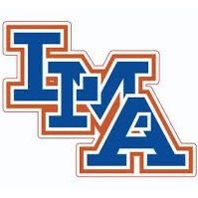

2021 Varsity Volleyball

Kendal Clark
Kassi Beard
Malorie Spiegel
Lindsey Barwick
Madison Rainwater
Laura Betts Brogdon
Ariana Somecheen
Maddy Lyles
Elizabeth Nesbitt
Caroline Ethridge
Abby Boldin
Hazel Grace Coker
Cheyanne Young

Head Coach: Amy Marshall
Assistant Coach: Baylee Elms

