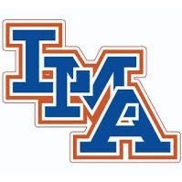
LMA Varsity Boys Basketball Roster 2020-21

Gabe Harris 12th
AJ Nelson 12th
Mason Dalrympe 12th
Aaron Medley 11th
Kaden Nivens 11th
Bryce Acord 11th
James Olden 10th
Jaden Sanders 10th
Brandon King 10th
Darius Moye 10th
Thomas Sumter 9th
Xavier Johnson 8th

